Year summary
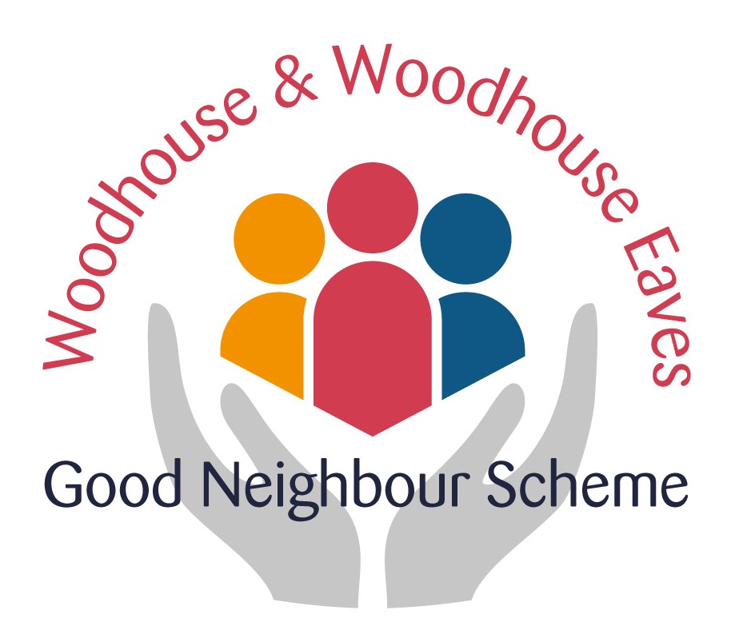
October 2016 to September 2017

We started the Good Neighbour Scheme exactly a year ago at the Scarecrow Festival 2016 and here we are to date having undertaken 185 jobs with 34 active volunteers. Nine of these volunteers form a steering group of Chairman, Secretary, Treasurer, Safeguarding, Telephone Coordinator, Companionship and Publicity Officers who meet at regular intervals and organise several open meetings to drive the scheme forward.

The most frequent requests are for lifts to hospital appointments and for companionship. It quickly became apparent that there needed to be a member of the steering group dedicated to managing the companionship side of the scheme. Two volunteers, Cherrie Whatmuff and Denise Croucher, offered to share this rôle and they now work together to carry out an initial visit, match a volunteer or volunteers to the resident, organise a rota if necessary and receive feedback. Sensitivity and compassion are required when offering companionship, in addition to friendliness and willingness to give up one’s time.

One of the outstanding strengths of the scheme is its inclusivity. All residents of Woodhouse and Woodhouse Eaves can avail themselves of the service provided and any task will be considered! To date we have managed to undertake the tasks ourselves but, if we do not have a volunteer with the necessary skills, then we can suggest alternatives, and we have compiled a list of other local organisations who offer specialised services. We help in any way we can so that the person requesting help receives that help, whether from us or another organisation. We are flexible and willing to adapt to circumstances as the need arises.

Another strength is that help with household tasks and companionship are completely free of charge to the person requesting the service. Lifts within the parish such as going to the surgery, picking up a prescription from the chemist or attending one of the village society meetings are also free. A charge is levied for lifts outside the parish, based on the mileage covered, so that the driver can receive 45p per mile towards running costs and fuel.

The cost of running the scheme includes insurance, the mobile phone, meeting costs, publicity materials and stationery. The biggest cost to date has been the Disclosure and Barring Service checks, but this will be spread over three years until the certificates are renewed. This will be changing eventually to the DBS checks being free in the future. The establishment of the scheme has been made possible by grants from the Rural Community Council, Woodhouse Parish Council and the SHIRE grant team at Leicestershire County Council. Donations from the Woodhouse Horticultural and Craft Show, the Woodhouse Scout Group and the May Day Challenge have provided additional funding and, most importantly, underline the outstanding support that the scheme enjoys within the community. Such support encourages the steering group to believe that the scheme is financially sustainable, cost-effective and will continue to grow and develop over the forthcoming years.

To raise awareness of the scheme and support other local groups, the Good Neighbour Scheme has attended the Scarecrow Festival, run by the Woodhouse Scout Group, in October 2016, the Annual General Meeting of the Woodhouse Parish Council and the Summer Funday organised by St Paul’s Church. In September 2017 the scheme was ready to assist with the Horticultural and Craft Show by giving lifts to those unable to get to the village hall without help.

Congratulations to everyone who has helped us this last year! As one volunteer put it when asked about how he felt about the scheme and his part in it: “I think it’s worthwhile. I’ve fixed a toilet and a computer and emptied a greenhouse to the tip. The sort of thing a family member might do for someone a bit older, but if you don’t have that help nearby….”.

Steering Group
4 October 2017

